DEPARTMENT OF BIOLOGICAL, CHEMICAL, AND PHYSICAL SCIENCE

ILLINOIS INSTITUTE OF TECHNOLOGY

PHYSICS 123

Newton’s Second Law

**Lab 3**

Markiyan Varhola

Date of Experiment: Sept. 17, 2015

Due Date: Sept. 24, 2015

Lab Section: 03

Lab Partner: Bhav Bhalla

TA: Clay Contee

**Abstract**

**Statement of Objective**

The object of this lab was to first obtain the density of different materials by measuring the dimensions of a solid object and its mass using in-lab equipment such as calipers and scales. The second experiment, regarding Hooke’s law, requires the proof of an empirical relation for springs by measuring the effect of weights on a spring’s stretch.

**Theory**

The density of an object can be found by using its mass and its volume. Since it is difficult to measure the density directly, one approach is to get the mass of the objects, and divide it by it’s volume. Volume can be calculated from the object’s dimensions, and for the purpose of this experiment, the objects were simple three dimensional shapes.

For Hooke’s law, the extension or compression of a spring is linearly proportional to the magnitude of the force exerted on it. The restoring force of the spring is always the opposite to the direction of the extension/compression of the spring but is proportional to a constant. The equation for Hooke’s law is as follows:

*Equation 1:*

$F=-kx$

Where F is the force, k is the spring constant, and x is the change in spring lenght. The negative sign is the restoring force.

**Equipment List**

* Aluminium cylinder
* Aluminium block
* Two cylinders of unknown density
* Calipers
* Balance (scale)
* Force Sensor
* Stand
* Ruler
* Spring
* Science Workshop 750 software and interface

**Procedure**

Density of Matter

Starting with an aluminium cylinder, measure the dimensions such as the diameter and the height. Repeat the measurement at least three times due to variances in caliper calibration. Then, weigh the objects on a balance, and calculate their mass (as the balance will report just the weight). Repeat the process for each object and record the data. Calculate the density by dividing the mass by the volume of the object.

Hooke’s Law

Turn on the Science Workshop 750 interface and start up the software. Connect the force sensor to an available input, and using the software choose a view that shows the value of the force sensor. Next, secure the force sensor on the stand, with the hook pointed toward the ground. Secure a ruler on the stand parallel to the force sensor. Then, place a spring on the hook, and press the tare button. After this, record the unstretched height of the spring. When everything is set up, place a mass of known weight onto the spring, and record the value of the force sensor along with the change in spring stretch. Repeat this process several times with different weights and springs.

**Data**

Density of Matter

The calipers and balance were used to record the dimensions and weight of different objects, and the object properties were recorded. Volume was calculated from the average of the dimensions for the object, as there were different shapes present.

|  |  |  |
| --- | --- | --- |
| **Object** | **Volume (avg)** | **Weight (avg)** |
| Aluminium cylinder | 4.6 $cm^{3}$ | 14.6 g |
| Aluminium block | 8.7 $cm^{3}$ | 24.7 g |
| Green Translucent cylinder | 13.7 $cm^{3}$ | 15.9 g |
| Purple Opaque cylinder | 10.7 $cm^{3}$ | 15.2 g |

*table 1: calculated volume and mass of each object*

Hooke’s Law

The change in stretch of the spring was measured from the end of the spring to the position on the ruler at eye level. The force was measured from the value given by the force sensor.

|  |  |  |
| --- | --- | --- |
| **Stretch of Spring (cm)** | **Weight of object (grams)** | **Force (N)** |
| 5.5 | 50.0 | .4 |
| 7.5 | 70.0 | .6 |
| 10.5 | 90.0 | .8 |
| 13.5 | 110.2 | .9 |

*table 2: stretch of spring and force measure by force sensor*

**Analysis of Data**

Density of Matter

The density of matter can be calculated using the following equation:

*Equation 2:*

$Density =\frac{Mass}{Volume}$

The following is the density of the objects measured, after performing the calculation.

|  |  |
| --- | --- |
| **Object** | **Density ($\frac{g}{cm^{3}}$)** |
| Aluminium cylinder | 3.1 |
| Aluminium block | 2.8 |
| Green Translucent cylinder | 1.2 |
| Purple Opaque cylinder | 1.4 |

*table 3: calculated density of various objects*

From the table, it can be seen that the density is similar for the two blocks of aluminium, and the average value for the density of aluminium can be calculating by getting the average of the two densities.

*Equation 3: Average density of Aluminium*

$\frac{3.1gcm^{-1}+2.8gcm^{-1}}{2}=2.9gcm^{-1}$

The average value for the density of Aluminium should be close to the result of this experiment.

Hooke’s Law

The original equation of Hooke’s law can be modified to find the value for k, or the spring constant:

*Equation 4:*

$-\frac{F}{Δx}=k$

When this equation is applied to the data from the previous table, the value of the spring constant can be calculated for the specific spring used:

|  |  |  |
| --- | --- | --- |
| $Δx$**(cm)** | **Force (N)** | **k (calculated)** |
| 5.5 | .4 | - .072 => -.1 |
| 7.5 | .6 | -.08 => -.1 |
| 10.5 | .8 | -.076 => -.1 |
| 13.5 | .9 | -.066 => -.1 |

*table 4: stretch of spring and force measure by force sensor*

The value for the spring constant stays almost constant as the other variables change, such as the force applied and the stretch. The force exerted and the stretch of the spring are linearly proportional as seen in the following graph:

*Graph 1: Force vs Spring Stretch*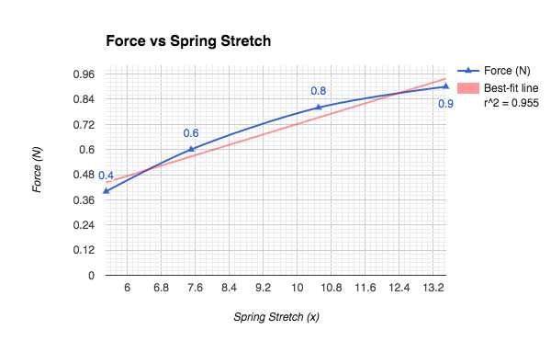

**Discussion of Results**

Density of Matter

The tabulated value for the density of Aluminium is $2.7gcm^{-1}$, which is very close to the result of this experiment. The difference in the density for the measured shapes could be due to external conditions, such as the temperature of the objects and the accuracy of the calipers.

Hooke’s Law

The graph’s slope represents the linear increase in force that is required to increase the stretch of a spring. The slope for the graph is almost linear, and the variations are due to external factors such as the accuracy of the force sensor and the human ability of perceive how far the spring has stretched. Since it is almost linear, is is similar to the value of k, the spring constant, which is used in the linear equation 1. Although the value of k is negative, it is just because the restoring force is pointed opposite to the force that acts on the spring.

Hooke’s law depends on the spring being used because different materials ahve different spring constants, and some are easier to stretch than others. Therefore, the value of k is unique to the spring being used.

Hooke’s law may also not hold for very large forces, as some springs may be stretched to the point that they are almost a string, and therefore any additional force that is applied does not stretch the spring.

**Conclusions**

The accuracy of the results was somewhat dependent on external factors such as the environment and the accuracy of the measurement methods. The limited accuracy of the equipment limited the extent of the measurements, however the results came close to the actual tabulated values for the first experiment. As for hooke’s law, the procedure used in the experiment allowed for the calculation of the value of k, although the results would be more accurate if more trials were conducted. Hooke’s Law therefore holds true for certain situations as previously explained.